Getting Started AOAME Locally

AOAME can be used locally or online. In the following, first the step-by-step guideline to get started with AOAME locally is provided.

## Prerequisite:

* [JDK version 1.8](https://www.oracle.com/technetwork/java/javase/downloads/jdk8-downloads-2133151.html) should be installed
  + (see guide at <https://confluence.atlassian.com/doc/setting-the-java_home-variable-in-windows-8895.html>)
* Download and install Node.js
  + <https://nodejs.org/en/download/>
* Download and install the IDE WebStorm: <https://www.jetbrains.com/webstorm/>
  + You can apply for a Free Educational License: https://www.jetbrains.com/community/education/#students
* Open with GitHub Desktop or Download ZIP file AOAME from the following repository:
  + <https://github.com/BPaaSModelling/AOAME>

**Quick setup (with scripts):**

Prerequisite:

1. Install Java JDK, Node.js, Git, Github, Jet Brain Westorm

Installation

1. Download the zip from:

https://github.com/BPaaSModelling/AOAME_Scripts/zipball/master

1. Extract all the files
2. Run Setup_local.

This will generate a folder that contain all the application.

1. Open GitHub desktop. Click on “add local repository” and select the folder “OntologyBasedModellingEnvironment-WebApp” in your AOAME folder in the desktop
2. Make sure you have selected Jet Brain Webstorm in this tab of Github Immagine che contiene testo

   Descrizione generata automaticamente
3. Click on Open in Jetbrains Webstorm
4. In the bottom left corner click on npm

1. Then in the window that appear in the bottom left corner click on build

1. When the building is complete, click on Heroku-start to start the server

1. Now on the browser you can access to the application: type “ localhost:4200 “ in the search web and press enter.

## Steps to launch the triplestore Apache Jena Fuseki and to load the ontologies:

1. Enter in folder *apache-jena-fuseki-3.4.0 and d*ouble-click on *fuseki-server.bat* to launch the Apache Jena Fuseki server
2. Open the browser (Google Chrome or Firefox are recommendable)
3. Type: <http://localhost:3030/> in the URL, then type Enter to open the Apache Jena Fuseki web interface (on the top-right corner the status server should show the greenlight, which means that the triplestore is up and running)
4. 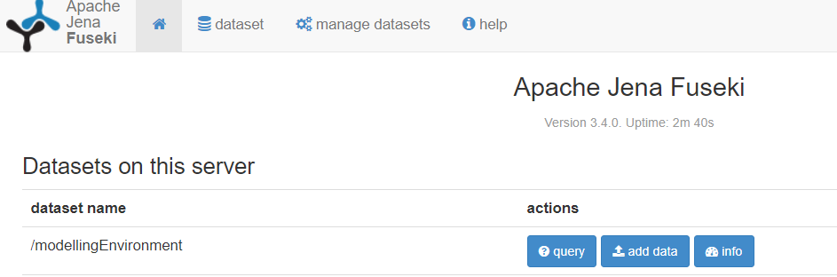Click on the blue button «add data», which corresponds to the dataset name */modellingEnvironment* (see red arrow in the screenshot below)
5. Click in the green button «+select files…»
6. Select the follwoing ontology files contained in the folder *Ontology4ModelingEnvironment.* 
   1. ModelingLanguageOntology.ttl
   2. DomainOntology.ttl
   3. PaletteOntology.ttl
   4. ModelOntology.ttl
   5. Add the remaining ontologies according to the Use Case of preference.
      * 1. For example, for extending BPMN select the following additional ontology files BPMN.ttl
7. Once they are selected, click on the «Open» button
8. Click on the «upload all» button from the Fuseki web interface. The latter should look similar to the below screenshot. The set of ontology is now uploaded on the triple store)

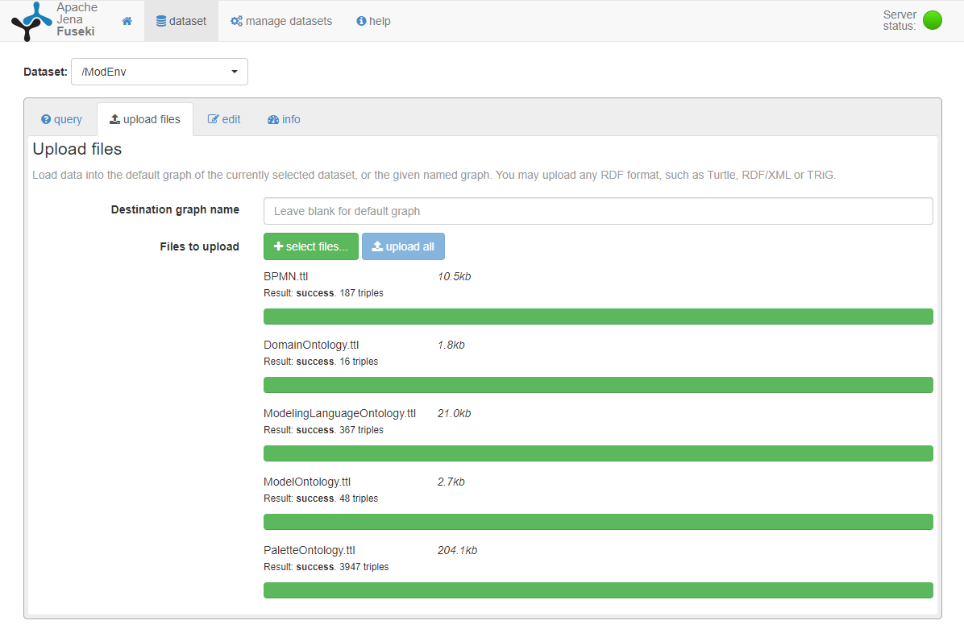

## Steps to launch the Web service:

1. Go to folder *OntologyBasedModellingEnvironment-WebService*
2. Double-click on *start webserver.bat* to launch the web service

## Steps to launch the WebApp (i.e. the GUI for the ontology-based modelling and metamodelling):

1. Open an Integrated Development Environemnt, e.g. [WebStorm](https://www.jetbrains.com/webstorm/) (<https://www.jetbrains.com/webstorm/>), from which the WebApp should be imported
2. Import the WebApp from the folder *OntologyBasedModellingEnvironment-WebApp*
   1. *File>Open>* …*\AOAME\OntologyBasedModellingEnvironment-WebApp*
3. Build package with all the dependencies:
   1. Right-click on “package.json”

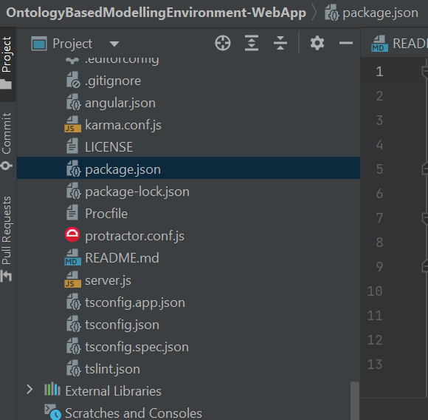

* 1. Run “npm” install
  2. If you receive an error or red color message, it might mean that Node.js is not configured properly.
     1. Configuring a local Node.js interpreter
     2. You may need to configure Node.js installation as an interpreter manually, for example, if Node.js is installed in a non-default location so WebStorm does not detect it automatically.
     3. Press Ctrl+Alt+S to open the IDE settings and select Languages & Frameworks | Node.js.
     4. Click next to the Node Interpreter list.
     5. In the Node.js Interpreters dialog with a list of all the currently configured interpreters, click on the toolbar and select Add Local from the context menu and choose the installation of Node.js, then click OK. You return to the Node.js Interpreters dialog where the Node interpreter read-only field shows the path to the new interpreter.
     6. In the Package manager field, choose the package manager (npm, Yarn, or pnpm) for the current project.
     7. See Configuring a package manager for a project for details.
     8. When you click OK, you return to the Node.js page where the Node interpreter field shows the new interpreter.
  3. In alternative, have a look into this guide for configuring Node.js correctly for WebStorm: <https://www.jetbrains.com/help/webstorm/developing-node-js-applications.html#ws_node_wsl>

1. Launch the WebApp
   1. Right-click on “package.json”
   2. Click on “Show npm Scripts
   3. double click on «heroku-start» (see screenshot below)

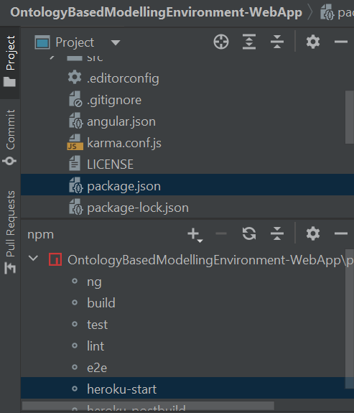

1. Open a new browser tab and type: <http://localhost:4200/modeller>. The palette and model editor are loaded on the web page (see screenshot below)

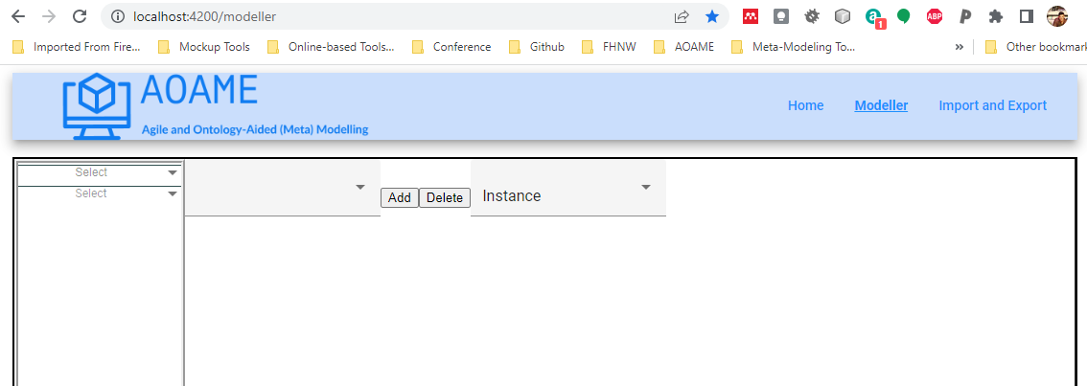

1. Select the modelling language from the first top dropdown (e.g. BPMN)
2. Select a modelling view (e.g. Process Modelling View)
3. The palette is now loaded and functionalities of AOAME can be used to adapt the language.

